**Child Abuse in America**

According to wfla.com, on January of 2015, a Pasco County daycare worker was caught on video kicking a 15-month-old girl while she was napping. 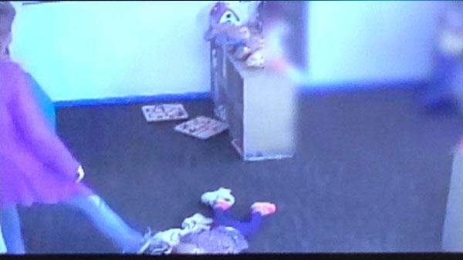

When the surveillance tape was viewed, it showed the daycare worker kicked and dragged the girl, who then woke up. Ten minutes after the girl fell back asleep, the daycare worker then kicked the little girl, forcefully, in the buttocks.

What exactly is child abuse? And how many children are suffering from abuse? What is America going to do about it? Child abuse is when a parent or caregiver, causes injury, death, emotional harm or put a child’s life at (Childhelp). According to the Federal Child Abuse Prevention and Treatment Act (CAPTA), child abuse and neglect is defined as,

"Any recent act or failure to act on the part of a parent or caretaker which results in death, serious physical or emotional harm, sexual abuse or exploitation"; or "An act or failure to act which presents an imminent risk of serious harm."

Their definition of child abuse and neglect refers specifically to parents and other caregivers. This usually refers to when a child is generally younger than 18. 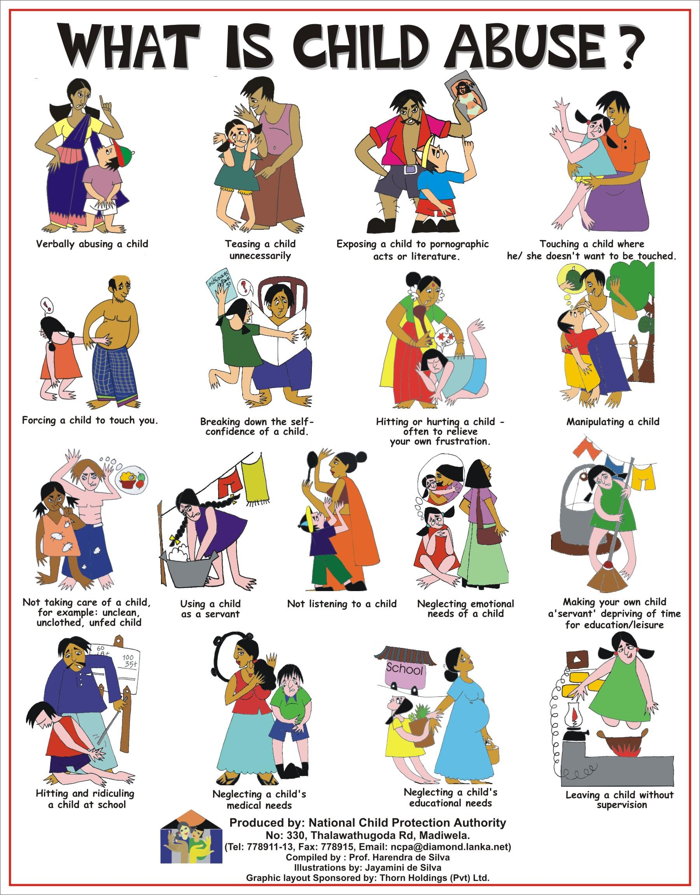

ASCA states that there are many forms of child maltreatment, including neglect, physical abuse, sexual abuse, exploitation, emotional abuse.

**Emotional abuse:** Emotional abuse refers to the psychological and social aspects of child abuse. This is the most common form of child abuse.

**Neglect:** This means that a parent or caregiver fails to provide or ignore a child's needs.

**Physical abuse:** Physical assaults are serious criminal offenses, for instance, hitting, slapping, or striking with an object. These types of physical abuse have been legally and socially sanctioned when parents abuse their children.

**Family violence:** Family violence, or domestic violence, usually refers to the physical assault of children and women by male relatives, usually a father and husband/partner. In these situations, violence is used to control his partner and children. Often times, males are known as the abuser, however, women may also be perpetrators of family violence. It is unusual for violent women to inflict the same scale of harm as violent men.

**Sexual abuse:** When an adult engages a minor in a sexual act, or exposes the minor to inappropriate sexual behaviour or material. Sexual abuse also involves contact and non-contact offences. A person may sexually abuse a child using threats and physical force, however, it usually involves subtle forms of manipulation. For example, the child is manipulated into believing that the activity is an expression of love, or that the abuse was their fault.

**Organised sexual abuse:** This occurs when multiple children are subject to sexual abuse by multiple perpetrators. In these circumstances, children are subject to a range of serious harms that can include child prostitution, the manufacture of child pornography, and bizarre and sadistic sexual practices, including ritualistic abuse and torture.

**Child sexual exploitation:** Children are sexually exploited for money, power or status. Children may be tricked into believing they're in a loving, consensual relationship. 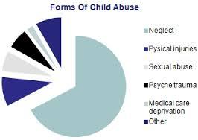

However, that is not always the case, they may be invited to parties, where they are given drugs, alcohol, and possibly sold online.

According to Safehorizon, 1 in 10 children suffer from maltreatment and 1 in 16 children suffer from sexual abuse. In the United States as of 2012, 1,593 children have died from neglect or abuse. Of that 1,593, 70.3% of the children were under the age of three and 44.4% were under the age of one.

Both male and female abuse rates are similar, 48.5% of the children abused or neglected were boys and 51.2% were girls, however in 2012, the rate of boys increased to 57.6%. In order to help children who are abused, it is important to report any suspicions to the police, a social worker, or a child abuse hotline.

There have been 2.9 reports of child abuse in the United States (17% came from teachers, 17% law enforcement, and 11% social workers). In 2012, 80% of the child abuse cases, the parent was the abuser.

Effects of child abuse can lead long into the victim’s life, and often times can be pretty severe. There are many long-term effects that have been observed, but the negative impacts of child abuse include poor mental health, unhappiness, and poor physical health.

Victims of child abuse often times show signs of trust issues, which leads to trouble forming relationships. Some other signs of a child being abused are unexplained injuries, fear of going home, change in school performance and attendance, changes in behavior. Because of their abuse, victims often times have a negative view of life, and are therefore more likely to turn to drugs and alcohol as an “escape” from the abuse.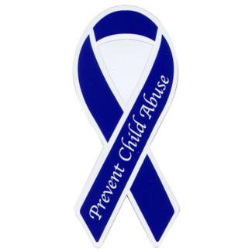

The prevention of abuse starts with informing and educating parents, teachers, and other children. Young parents especially need to be informed and educated on how to care for their children and the value of patience. Parents can be stressed and exhausted while taking care of their children and need a break once in a while. They need to relax and be in a peaceful state of mind in order to be patient with their children. It is important to understand and know your kids to know how to handle them and control them. Violence is never a solution.

If you and/or your child or a child that is being abused needs help, they can call the ChildHelp National Child Abuse Hotline. The ChildHelp National Child Abuse Hotline has people, who speak all different languages, waiting to pick up your call 24 hours a day, 7 days a week ready to provide help with crisis intervention, provide information about child abuse, literature that you can read to hopefully help out the child. There are referrals to counseling, social services, and support resources available. All calls are confidential and will always be available to help assist you with any child abuse problems you have.

Works Cited

Adults Surviving Child Abuse. *Types of Child Abuse*. March 12, 2015.

<http://www.asca.org.au/about/resources/types-of-child-abuse.aspx>

Childhelp.*What is Child Abuse*. February 11, 2015.

<https://www.childhelp.org/child-abuse/>

Safe Horizon. *Child Abuse Facts*. February 11, 2015.

<http://www.safehorizon.org/page/child-abuse-facts-56.html>

WFLA News Channel 8. *Pasco daycare worker kicked child in head*. Jan 20,

2015.

<http://www.wfla.com/story/27894419/sheriff-pasco-daycare-worker-kicked-child-in-head>